EXPERIMENT-9
9.A person has two containers of different capacities and must measure an exact quantity of water. Solve the Water Jug Problem. Generate the sequence of operations to reach the goal state.

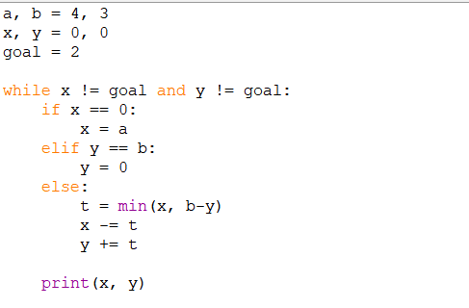
PROGRAM:

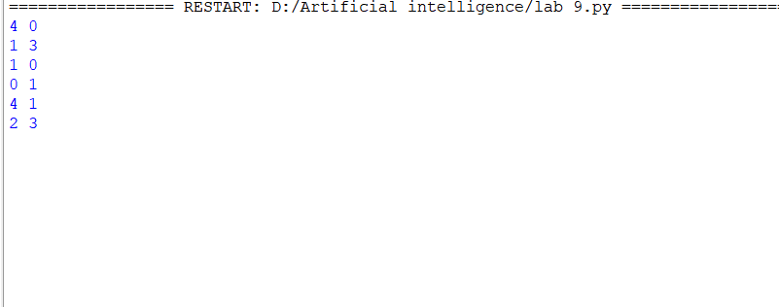
OUTPUT:

